**Route Planner**

In google maps you can search for a route to a destination and google will analyze the different possible routes and highlight the best route. Typically, 2-3 routes are shown. For each route ,the length and duration are displayed.

Routes are composed of short straight segments. Based on the latitude and longitude of the start and end points the length of these segments (km) can be calculated based on the following formula:

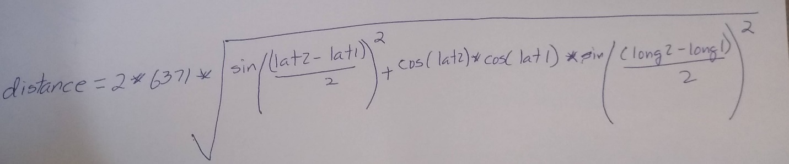

Start Point

* lat1, long1 – in radians

End Point

* lat2, long2 – in radians

The latitude and longitude will be input as degrees from the user but need to be converted to Radians **before** being used in the formula. Use Math.toRadians() to convert degrees to radians.

**Route File**

A route file is constructed of a number of points that designate the segments of the route. This route is for Point A to Point C. The first line is just a description that should be ignored by your program. To drive the route there would be two road segments based on the file:

SAIT Polytechnic to Scotiabank Saddledome Route 2  
51.06462917144981, -114.0864067825141, 20  
51.06293706734136, -114.08640792330227, 30  
51.058508622831475, -114.08599125943302, 0

A

C

B

The Segments would be

Segment 1 (A to B)

* Start Point:
  + 51.06462917144981, -114.0864067825141
* End Point
  + 51.06293706734136, -114.08640792330227
* avgSpeed
  + 20 KPH

Segment 2 (B to C)

* Start Point
  + 51.06293706734136, -114.08640792330227
* End Point
  + 51.058508622831475, -114.08599125943302
* avgSpeed
  + 30 KPH

**Class Design**

You will need three classes to implement this project:

1. Point Class
   1. The attributes of a Point are
      1. double latitude
      2. double longitude
   2. The methods should be implemented as outlined in ‘Point.html’
2. Segment Class
   1. The attributes of a Segment are
      1. Point start
      2. Point end
      3. double avgSpeed
   2. The methods should be implemented as outline in ‘Segment.html’
3. RouteAnalyser
   1. This program will be the application that create routes based on segments and analyses them.
   2. You will be given the skeleton code for RouteAnalyser and will be expected to fill in the missing methods.

All the classes should be placed within the same project.

**Creating your own Route Files**

To create your own route file go to [www.google.ca/maps](http://www.google.ca/maps) and establish a start and end destination. Then go into the map and identify the straight segments and their lat/long along the route. To figure out the lat/long in google maps right-click on a point in the road and then in the pull-down select the lat/long to copy the data to the clipboard. You can then paste this data into a text file along with an estimate of the speed limit for that segment. You don’t have the same real-time data for the average speed for each segment but your distances should be very similar!

**Development Process and Grading Rubric**

Software developer often develop systems using an incremental approach. In an incremental approach there are multiple releases of the software, each release building on the previous. For this project the following releases are recommended:

1. Build Point Class 2 Marks
   1. Test Program – run the program TestPoint.java to verify your class
2. Segment Class 3 marks
   1. Test Program – run the program TestSegment.java to verify your class
3. Route Planner 5 marks
   1. Test Program
      1. Run your program with the route file provided (saitsaddledome1.txt) and verify the length and duration on the route versus the following sample run:

Results from Option 2 Analyze Route

Route data

Description Value

Segments 6

KM 5.6

Minutes 9